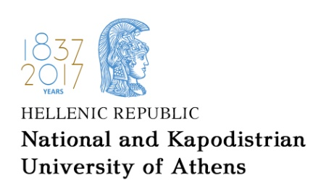

SCHOOL OF EDUCATION
FACULTY OF EARLY CHILDHOOD EDUCATION
UNIVERSITY COLLEGE LONDON, INSTITUTE OF EDUCATION
JOINT MA “EDUCATION AND HUMAN RIGHTS”

Joint MA Programme ‘Education and Human Rights’
Interdisciplinary Seminar:
Education, Human Rights and Social Inequalities
11 - 14 September 2017
13A NAVARINOU STR, GROUND FLOOR, CONFERENCE ROOM

Monday 11 September 2017
15.00 - 15.30 | Evie Zambeta and John Vorhaus | Welcome
15.30 - 16.30 | J. Vorhaus | Profound disability, equality and citizenship
16.30 - 17.30 |  | Working groups and Discussion
17.30 - 18.00 |  | Break
18.00 - 19.00 | D. Makrinioti | The politics of population
19.00 - 20.00 |  | Working groups and Discussion

Tuesday 12 September 2017
15.30 - 17.00 | Joint MA Graduates | Presentations of MA dissertations (see below: names, topics and supervisors)
18.00 – 21.00 |  | Incoming students’ welcome session

Wednesday 13 September 2017
15.00 - 16.00 | M. Leontsini & Y. Papadakou | Democratic school governance for inclusion: a whole community approach. a. Mobilities
16.00 - 17.00 |  | Working groups and Discussion
17.00 - 17.30 |  | Break
17.30 - 18.30 | E. Zambeta & Y. Papadakou | Democratic school governance for inclusion: a whole community approach. b. Governance
18.30 - 19.30 |  | Working groups and Discussion

Thursday 14 September 2017
15.00 - 16.00 | J. Suissa | The Right to Have Rights? Some Philosophical Reflections on Being at Home
16.00 - 17.00 |  | Working groups and Discussion
17.00 - 17.30 |  | Break
17.30 - 19.00 | Joint MA Graduates | Presentations of MA dissertations (see below: names, topics and supervisors)

Tuesday 12 September 2017 - Presentations of MA Dissertations
 | Graduates | Dissertation topic | Supervisor
15.30-15.50 | Alexandra-Maria Margouta | Educational practices and parents’ perceptions of schooling of their children in the neighborhood’s “good” school | N. Askouni
15.50-16.10 | Discussion
16.10-16.20 | Break
16.20-16.40 | Konstantinos Basbas | Teachers as parents: strategies and practices in their children's education | N. Askouni
16.40-17.00 | Discussion

Thursday 14 September 2017 - Presentations of MA Dissertations
 | Graduates | Dissertation topic | Supervisor
17.30-17.50 | Nikolaos Mavroudis | "Stories of Human Rights, Democracy and Citizenship". The example of migrants / refugees in Greece of "Crisis" | D. Makrinioti
17.50-18.00 | Discussion
18.00-18.20 | Break
18.20-18.40 | Vretti Anthoula | National Union Hellas: an anti-Semitic and anti-communist organization in Greece during the interwar period | F. Asimakopoulou
18.40-18.50 | Discussion

